**Set Up Guide for Natural Language Processing (CS 5316)**

* Please download and install the Anaconda Navigator(Python version 3.7), site link: <https://www.anaconda.com/distribution/>

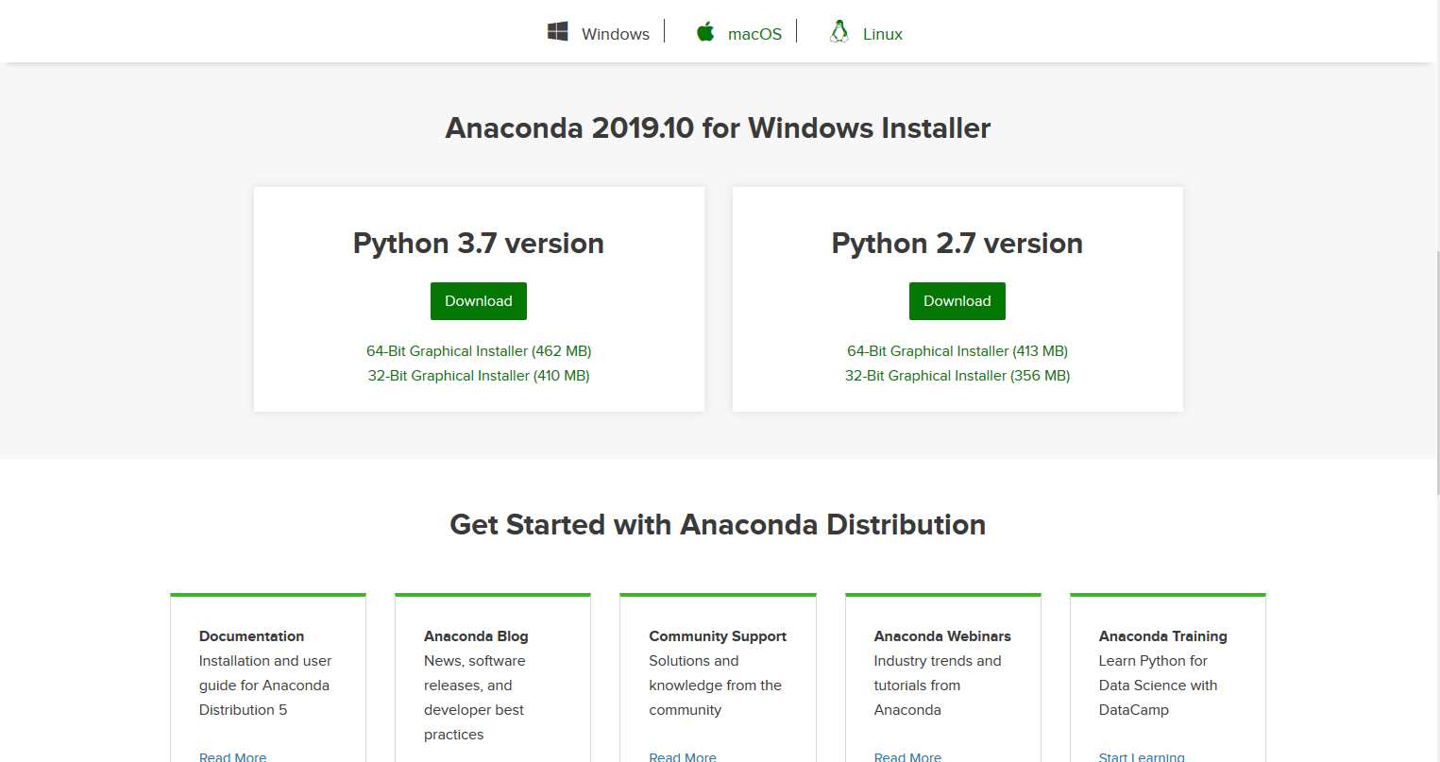

* After install anaconda navigator, open the environments tab as shown below:

You can either create a new environment(recommended) by clicking the create option or install all the required packages in root, multiple environments are usually used to manage different projects that may be based on different python versions.

* After clicking create the following dialog box will pop up:

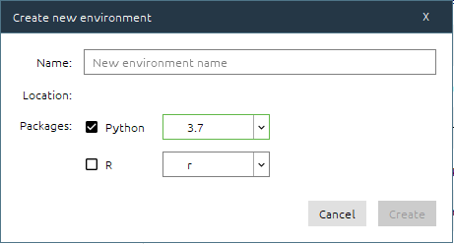

Select required version (3.7 in our case), enter a name for environment and click create.

* Select the new environment(py in my case) and select All from the drop-down box as shown below:

* Search and select all the packages in the list below(ignore the ones that are already installed), then click install:
  + Nltk
  + pandas
  + Numpy
  + Tensorflow
  + Matplotlib
  + Gensim
  + spaCy
  + tabulate
  + Scikit-learn
* If any of the packages are not available, you can install them through the terminal. Click the play button beside your environments name and click “open terminal”, search online for pip install or conda install commands related to those packages and run them in the terminal.
* To run the Jupyter notebook click the play button and select the option run with Jupyter Notebook:

